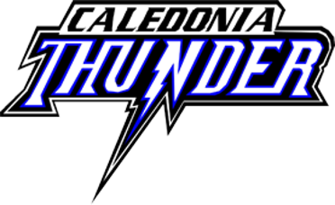
Attention CDMHA Supporter
We once again find ourselves on the verge of another terrific hockey season, the 2018/19 season aligning to be fun, successful and most of all full of learning for the players of Caledonia Minor Hockey.
Registration remains strong, with hopes of growth with the additional developments coming to our town. We will be having over 24 Local league teams this year from Initiation through Midget and will have REP and AE teams competing from Novice to Midget as well. In all our over 500 players will be coached to have fun, play as a team and make their home town proud!
CDMHA is proud to remain running on a balanced budget, this year placing more emphases on player development and assisting our coaches in training and certifications. We also have decided to go with one style of jersey for both Local League and REP and AE to ensure we are treating all players with the same level of respect.
Once again however we are asking for your support in making the season a success. Without you, we would struggle to provide the program we do, and want to ensure that you are part of our community hockey program. We would ask you take a minute or two to review the sponsorship opportunities attached.
Your commitment will ensure we can continue to provide the best possible hockey program we can, developing players that have potential to represent our town in bigger communities and provide the health, learning and joy hockey brings to those who both play it and support it
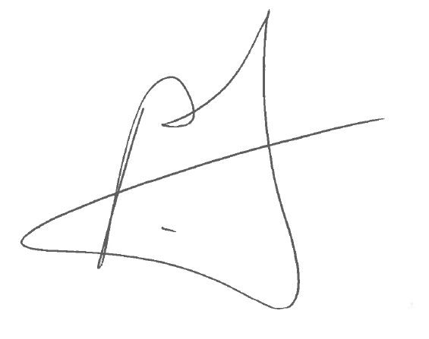
Paul Makey
President CDMHA
president@caledoniathunder.com
905-745-9930

CALEDONIA MINOR HOCKEY AND OUR COMMUNITY

Supporting those who support us!

- 500+ players and families living in our community and sourcing there needs from business like you.

- 100+ Visiting Teams and their families buying gas, food and other needs from the businesses in Caledonia and area over a season.

- Caledonia Challenge Cup bringing 60+ teams to town for a 3 day tournament. Hundreds of families eating, shopping and lodging in our region.

Giving back to our community!

- Teams performing Charitable Fund Raisers and Food Drives

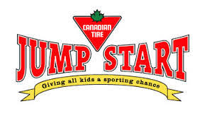
- CDMHA is a big supporter of Canadian Tire’s Jump Start program providing finical assistance to families in the region for hockey.

2018 SPONSORSHIP OPPORTUNITIES
Please review the following sponsorship opportunities we have. If you do not see something that meets your wishes, please feel free to reach out our VP of Business who can work with you to contribute.

- REP and AE Jersey Sponsor
Company Name/Logo on the back of a team’s Jersey for one season
- REP or AE Home Jersey Sponsorship $450.00
- REP or AE Away Jersey Sponsorship $350.00
- REP or AE Team Home and Away Jersey Sponsorship $700.00
All sponsors at this level will also have their logo on the CDMHA website for one season as well and receive season passes to all CDMHA games in Caledonia.
- Local League Jersey Sponsorship
Company Name/Logo on the back of a team’s Jersey for one season
  - One LL Team one Season $300.00
All sponsors at this level will also have their logo on the CDMHA website for one season as well and receive season passes to all CDMHA games in Caledonia.

- Gold Level Sponsor $1,000.00
All Gold Level Sponsors will receive their logo
  - On a REP or AE Home and Away Jerseys
  - Recognition at the Challenge Cup in the program, on website and mentioned during all playoff games
  - Logo on the in house TV monitors at the Arena
  - Season passes to all CDMHA games in Caledonia.

- Contributor, any contribution of funds or in kind gifts over $50.00. This may include items for the Challenge Cup Raffle table, cash or other items the CDMHA can use.

All sponsors of $350.00 or above will receive a team mounted picture recognizing their contribution.

2018/19 SEASON SPECIAL

Become a CDMHA Supporter and receive 6 Season Passes for all CDMHA Home Games during the regular Season.
Promote your business by having a raffle to win a pair or all six passes. Families and their extended families will come into your business to win these!

